Criar Resource de User

userSrv.js

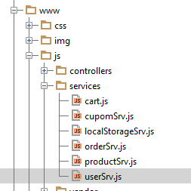

**angular**.module(**'starter.services'**).**service**(**'User'**, [**'$resource'**, **'appConfig'**, **function** ($resource, appConfig) {  
 **return** $resource(appConfig.**baseUrl** + **'api'**, {}, {  
 **authenticated**: {  
 **url**: appConfig.**baseUrl** + **'api/authenticated'**,  
 **method**: **'GET'** },  
 **query**: {  
 **isArray**: **false** }  
 });  
}]);

Importar no Index.hmtl

<**script src="js/services/userSrv.js"**></**script**>

Testando em ClientCheckoutController

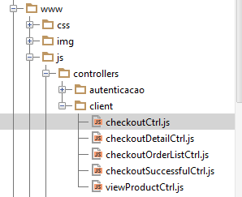

**angular**.module(**'starter.controllers'**)  
 .**controller**(**'ClientCheckoutCtrl'**,[  
 **'$scope'**, **'$state'**, **'$cart'**, **'Order'**, **'$ionicLoading'**, **'$ionicPopup'**, **'Cupom'**, **'$cordovaBarcodeScanner'**, **'User'**,  
 **function** ($scope, $state, $cart, Order, $ionicLoading, $ionicPopup, Cupom, $cordovaBarcodeScanner, User) {  
 **var** cart = $cart.get();  
 $scope.**cupom** = cart.**cupom**;  
 $scope.**items** = cart.items;  
 $scope.**total** = $cart.getTotalFinal();  
  
 User.**authenticated**({**include**: **'client'**}, **function** (data) {  
 ***console***.**log**(data.data)  
 }, **function** (responseError) {  
 ***console***.**log**(**"ERRO"**);  
 });